**Lesson 5 Demo 9**

**Understanding Daemon Sets**



Steps to be followed:

1. Creating a Daemon Set

**Step 1: Creating a Daemon Set**

1. Create a file with the following command:

***vi rolupdatedaemon.yaml***



1. Write the following code in the file:

***apiVersion: apps/v1***

***kind: DaemonSet***

***metadata:***

***name: fluentd-elasticsearch***

***namespace: kube-system***

***labels:***

***k8s-app: fluentd-logging***

***spec:***

***selector:***

***matchLabels:***

***name: fluentd-elasticsearch***

***updateStrategy:***

***type: RollingUpdate***

***rollingUpdate:***

***maxUnavailable: 1***

***template:***

***metadata:***

***labels:***

***name: fluentd-elasticsearch***

***spec:***

***containers:***

***- name: fluentd-elasticsearch***

***image: quay.io/fluentd_elasticsearch/fluentd:v2.5.2***

***volumeMounts:***

***- name: varlog***

***mountPath: /var/log***

***- name: varlibdockercontainers***

***mountPath: /var/lib/docker/containers***

***readOnly: true***

***terminationGracePeriodSeconds: 30***

***volumes:***

***- name: varlog***

***hostPath:***

***path: /var/log***

***- name: varlibdockercontainers***

***hostPath:***

***path: /var/lib/docker/containers***

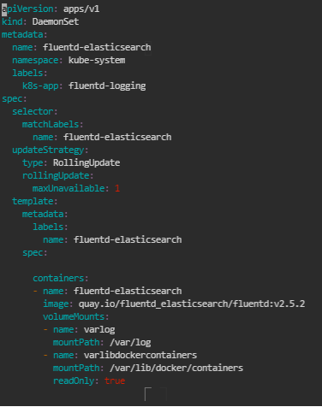

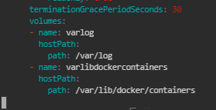

1. Write the following command:

***kubectl apply -f rolupdatedaemon.yaml***



1. Write the following command:

***kubectl get ds -A -o wide***

